Milling:
Milling is the mechanical process of particle size reduction of solids through various operations such as comminution, crushing, grinding, or pulverization. The primary pharmaceutical objective of milling is to produce fine particles, which significantly increases the specific surface area (surface area per unit weight) of the material.

In general, a 10-fold decrease in particle size results in a 10-fold increase in surface area, a change that profoundly impacts the material's physical and therapeutic properties.
Size reduction through milling is essential for several reasons:
- Dissolution and Efficacy: It increases the area of contact between the solid and dissolving fluids, enhancing the dissolution rate and therapeutic efficiency of medicinal compounds with low solubility.
- Formulation Uniformity: Milling ensures that solid ingredients are of a similar size, which is critical for uniformity of dose and preventing mottled appearances in colored pharmaceuticals.
- Process Facilitation: It facilitates the extraction of drugs from animal or vegetable sources by shortening the solvent's penetration distance. It also aids in drying wet masses by increasing the surface area for moisture evaporation.
- Product Quality: In inhalational products, size determines position and retention in the bronchopulmonary system; in ointments and creams, fine particles provide a smooth texture and improved physical stability.
Mechanisms of Comminution
Size reduction occurs through four main mechanisms:
- Cutting (using sharp edges).
- Compression (crushing between surfaces).
- Impact (striking with a fast-moving part).
- Attrition (breaking via shear forces from surfaces moving relative to each other).
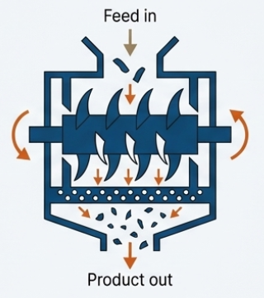
1. Cutting
- Primary Mechanism: The application of force over a very narrow area of material using a sharp edge.
- Principle of Operation: In a cutter mill, a horizontal rotor with knives rotates within a casing that has stationary knives; the material is reduced in size by a successive shearing action as it passes between these blades.
- Critical Operating Parameters: The rotor speed (typically 200 to 900 rpm), the number of knives, and the mesh size of the screen that controls discharge size are vital.
- Application: This mechanism is essential for tough, fibrous materials (such as crude vegetable drugs like Glycyrrhiza or Rauwolfia) that cannot be crushed by pressure or impact. It is not used for friable materials.
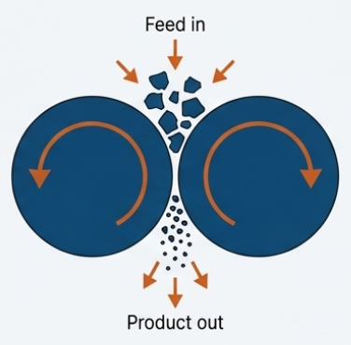
2. Compression
- Primary Mechanism: The material is gripped between two surfaces and crushed by the application of pressure.
- Principle of Operation: In instruments like the roller mill, material is pulled into the narrow gap between smooth rollers rotating at different speeds, effecting reduction through both pressure and shearing. In runner mills, the weight of a heavy muller (edge-runner) or a pestle (end-runner) provides the compressive force.
- Critical Operating Parameters:
  - The weight of the grinding media (mullers or pestles) and the clearance/speed of the rollers.
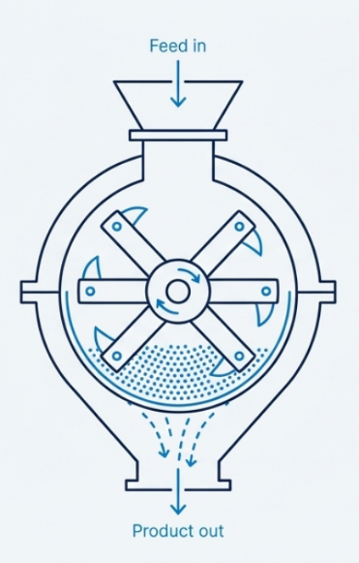
- Application: Compression is typically used for soft materials and the wet grinding of viscous materials like ointments and pastes.
3. Impact
- Primary Mechanism: This involves the contact of the material with a fast-moving part, or the material striking a stationary surface, which imparts kinetic energy to the particle. This creates internal stresses that fracture the material.
- Principle of Operation: Hammer mills utilize high-speed rotors (up to 10,000 rpm) with swinging hammers that strike the feed material. In fluid-energy mills, particles strike the walls of the grinding chamber at high velocities.
- Critical Operating Parameters:
  - Rotor speed is the most crucial parameter; if the speed is below a "critical impact speed," the mill may function as a blender rather than a comminutor.
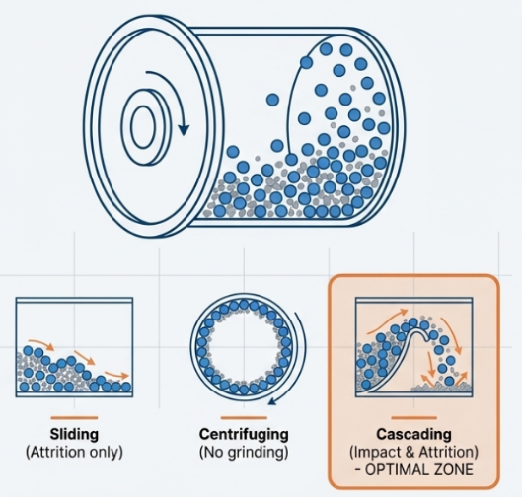
- Application: Impact milling is versatile and used for almost all drugs, including dry materials and filter-press cakes. It tends to produce sharp, irregular particles.
4. Attrition
- Primary Mechanism: The material is subjected to pressure, but the surfaces are moving relative to each other, resulting in shear forces that break the particles.
- Principle of Operation: In a ball mill rotating at low speeds, balls roll and cascade over one another, providing attrition. In a pin mill, material is propelled through intermeshing rings of pins by centrifugal motion, where reduction occurs through both impact and attrition.
- Critical Operating Parameters:
  - The solids feed rate and rotor speed are key; in ball mills, the critical speed (where balls begin to centrifuge rather than cascade) must be avoided for effective attrition.
- Application: Attrition is ideal for producing fine grinding of hard, abrasive materials. Unlike impact, it often produces free-flowing spheroidal particles.
To better visualize these processes, imagine a kitchen: Cutting is like using a chef’s knife to slice through a tough celery stalk; Compression is like crushing a garlic clove under the flat side of that knife; Impact is like smashing a peppercorn with a meat mallet; and Attrition is like rubbing a dried herb between your palms to break it into a fine powder.
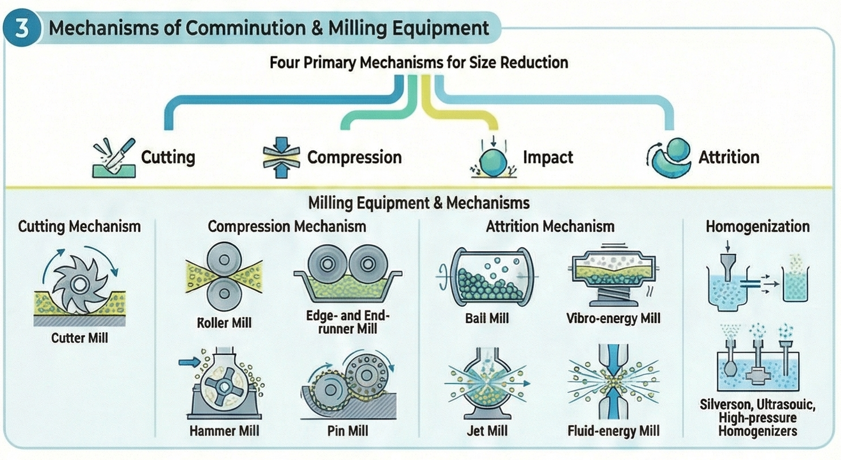
Theory of Comminution:
The science of milling, or comminution theory, explores how materials fracture under stress.
Mechanical Behavior: Stress and Strain
The theory of how materials break during milling is based on their mechanical behavior under stress. When a solid is subjected to force, it goes through several stages:
- Elastic Deformation: Initially, the material strains but will return to its original shape if the force is removed; this is defined by Hooke's Law, where stress is proportional to strain.
- Yield Point: This is the point where the material can no longer resist permanent change.
- Plastic Deformation: Beyond the yield point, the material is permanently deformed.
- Fracture: With enough force, the material reaches its fracture strength and breaks. The energy required to cause this fracture is known as the material's impact strength.
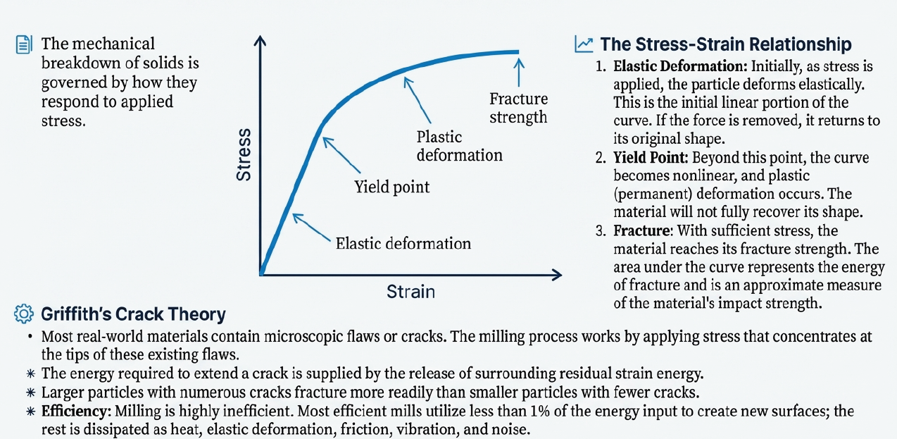
According to the Griffith theory, all solids contain microscopic cracks that focus applied force at their apexes, leading to fracture when the energy exceeds the bond strength. Three primary laws describe the energy required for this process:
- Kick’s Law: States that energy is related to the reduction ratio, applying best to coarse milling.
- Rittinger’s Law: Assumes energy is proportional to the new surface area created, most applicable to brittle materials undergoing fine milling.
- Bond’s Law: Suggests the energy required is inversely proportional to the square root of the product diameter.
Notably, the milling process is relatively inefficient; less than 1% of the energy input is typically used to fracture the particles and create new surfaces, while the remainder is dissipated as heat, friction, vibration, and noise.
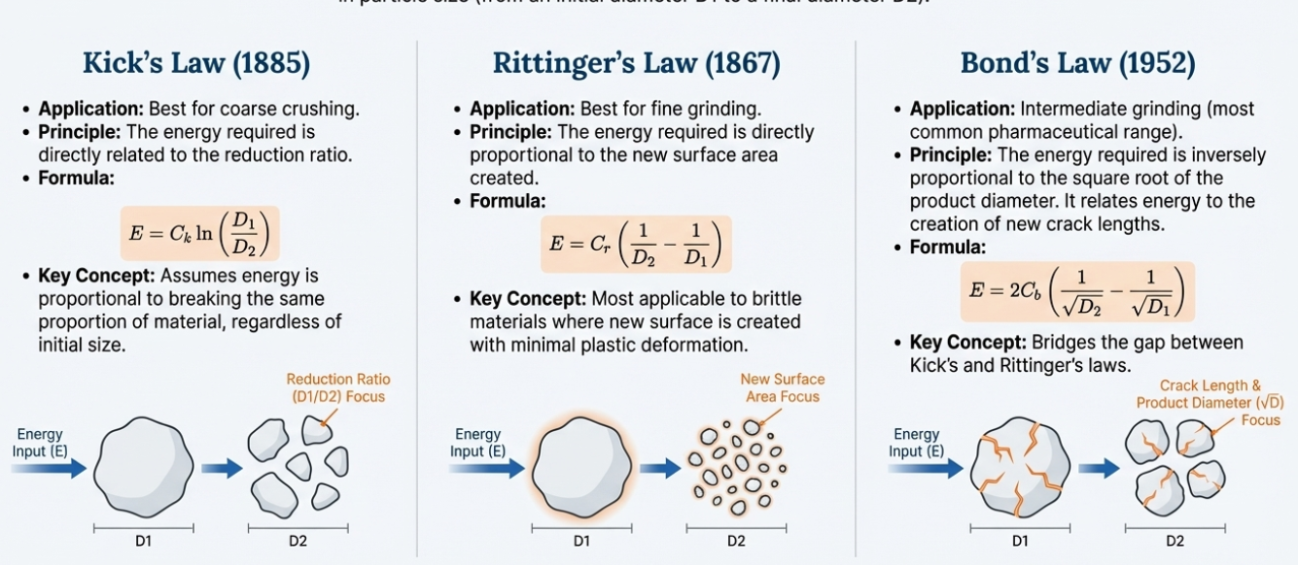
Milling Rate and Limits
The speed at which material breaks down is called the milling rate. For brittle materials in a batch process, this follows a first-order rate law, meaning the number of particles that survive breaking decreases exponentially over time, similar to radioactive decay.
However, there is a limit to comminution. It is theoretically impossible to mill materials to "unlimited fineness". As particles become extremely small (around 10⁻³ µm), they have fewer cracks left to start a new break. At this stage, the energy required to create new cracks increases so much that further milling becomes useless, and particles may even begin to stick together or aggregate.
How Milling Facilitates Drying
The sources state that the drying of wet masses is improved by milling because it:
- Increases Surface Area: This provides more area for moisture to evaporate.
- Reduces Diffusion Distance: Moisture has a shorter distance to travel from the center of the particle to reach the outer surface.
- Uniformity: Sieving a wet mass before drying ensures more rapid and uniform drying.
- Stability: Micronization followed by drying can increase stability by removing occluded (trapped) solvents.
Moisture Content and Milling Efficiency
The moisture level in a material dictates how it should be milled:
- Inhibiting Moisture: The presence of more than 5% water hinders comminution and can create a sticky mass.
- Dry Milling Requirement: For dry milling, moisture content should typically be less than 2%.
- Wet Milling: If moisture is greater than 50%, the material becomes a slurry, and the process is classified as wet milling.
Dual Processing
The sources note that milling can serve as a drying process simultaneously. If hot gas is circulated through a mill, it can comminute and dry moist solids at the same time. In a fluid-energy mill, compressed air expands at the orifice, creating a cooling effect that can protect heat-sensitive materials during the process.

Equipment and Selection
Milling equipment is classified as coarse, intermediate, or fine depending on the final product size. Common mills include:
- Hammer Mill: A versatile impact mill used for almost all drugs, though it should be avoided for highly abrasive materials.
- Ball Mill: Uses a rotating vessel with steel balls or pebbles to achieve size reduction via impact and attrition; it is ideal for fine grinding of hard or abrasive materials.
- Fluid-energy Mill (Micronizer): Uses high-velocity gas to cause particles to impact each other, producing very fine powders (1 to 20 µm) without moving parts.
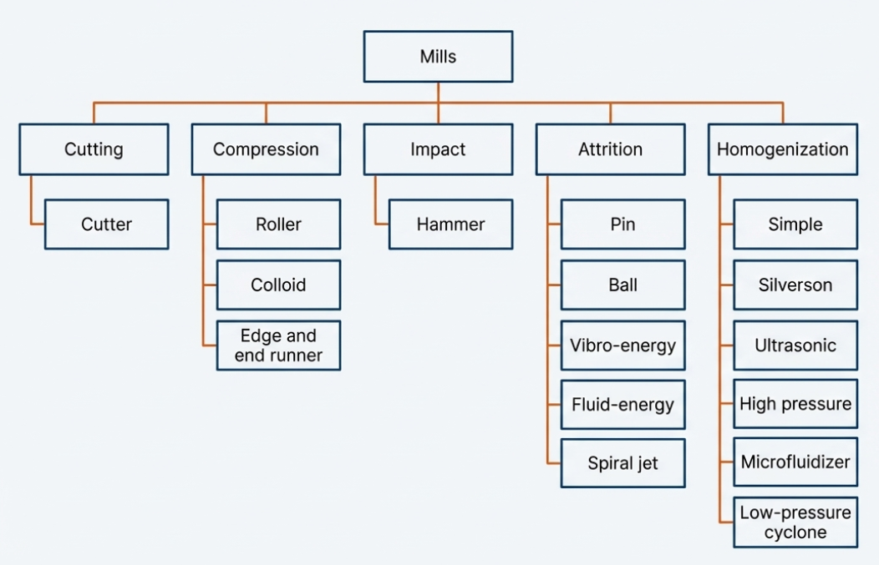
- Cutter Mill: Employs a cutting action, making it suitable for fibrous or crude vegetable drugs.
Selecting the right mill depends on product specifications (size, shape), moisture content, and the physical nature of the material, such as whether it is hard, soft, or thermolabile (heat-sensitive). For instance, materials with a low melting point may soften or melt due to the heat generated during milling unless cooling techniques, like cooling jackets or dry ice, are employed.
Apparatus based on mechanism:
The apparatus used for pharmaceutical milling—the process of reducing the particle size of solids—are categorized primarily by their mechanical methods of action: cutting, compression, impact, and attrition.
The following is a detailed discussion of these instruments, structured by their mechanisms and specific operating characteristics.
1. Cutting Mechanism
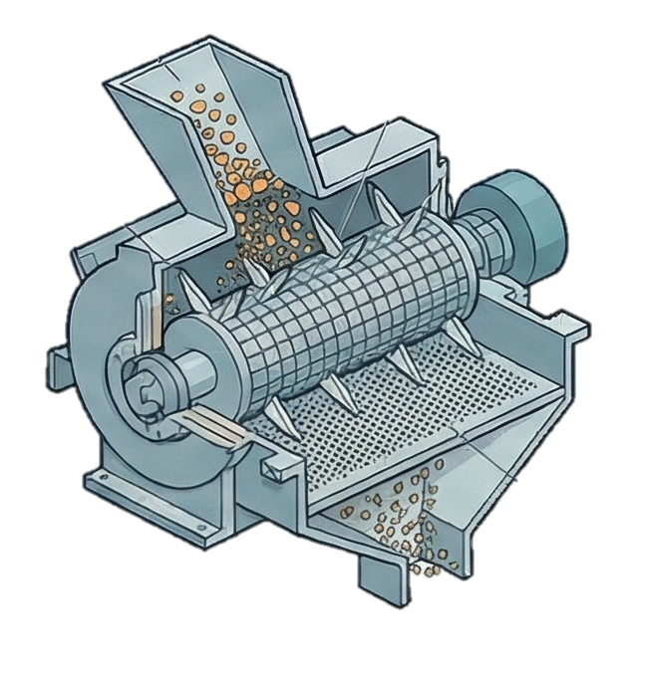
Cutting involves applying force over a very narrow area using a sharp edge. This is ideal for materials that cannot be crushed, such as those that are fibrous or tough.
Cutter Mill
- Primary Mechanism: Cutting.
- Principle of Operation: The mill features a horizontal rotor equipped with 2 to 12 knives that turn at speeds of 200 to 900 rpm within a cylindrical casing containing several stationary knives. Size reduction occurs as the material is sheared between the rotating and stationary blades.
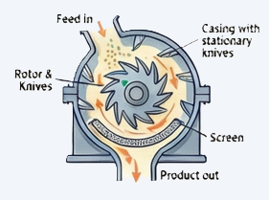
- Critical Operating Parameters: Rotor speed (200–900 rpm), the number of knives, and the mesh size of the screen at the bottom of the casing, which controls the discharge size. The feed size should ideally be less than 1 inch in thickness.
- Limitation: It is not suitable for friable (brittle) materials, and fibrous materials can sometimes align with the slots in the screen and pass through without enough reduction.
- How to Overcome: Using a circular hole design for the screen is recommended to prevent fibers from aligning and clogging the system.
- Advantages: It provides successive cutting action rather than attrition, making it ideal for tough substances.
- Pharmaceutical Applications: Used for processing fibrous materials, crude animal drugs, and vegetable drugs (e.g., Glycyrrhiza, Rauwolfia).
2. Compression Mechanism
In compression, the material is crushed between two surfaces by the application of pressure.
Roller Mill
- Introduction: Roller mills are used for smoothing and refining materials, particularly in the production of semi-solids.
- Mechanism: It effects size reduction through a combination of compression (gripping and crushing) and shearing.
- Construction: It typically consists of two to five smooth rollers that operate at different speeds.
- Working: Material is fed between the rollers. Because they rotate at different speeds, the material is crushed and then sheared as it passes through the gaps.
- Limitation: It is generally not used for abrasive materials as they can wear down the smooth rollers.
- How to Overcome: Ensure the feed is of the proper size and enters at a uniform rate to prevent overloading the rollers.
- Advantages: It produces a uniform product and is highly effective for fine-tuning the texture of preparations.
- Pharmaceutical Applications: Used for processing soft materials and refining ointments and pastes.
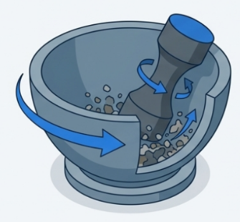
Edge-and End-runner Mills
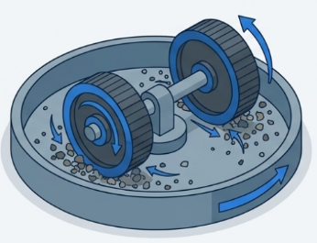
- Primary Mechanism: Compression and shearing.
- Principle of Operation: The edge-runner mill uses one or two heavy wheels (mullers) mounted on a horizontal shaft that roll in a heavy pan. The end-runner mill uses a heavy pestle mounted vertically in an off-center position within a rotating mortar.
- Limitation: They are not suitable for abrasive materials.
- Critical Operating Parameters: The weight of the muller or pestle and the speed of rotation.
- Application: Useful for moderately fine powders, fibrous materials, and wet grinding of viscous materials like ointments and pastes.
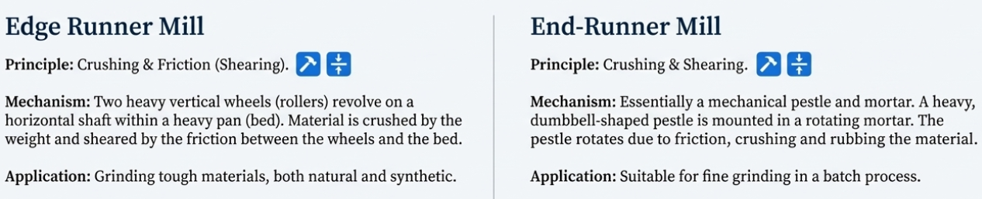
3. Impact Mechanism
Impact milling occurs when a fast-moving part strikes the material, or the material strikes a stationary surface, creating internal stresses that break the particles.
Hammer Mill
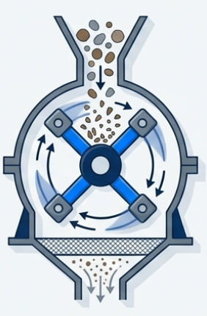
- Introduction: This is the most popular and versatile mill in pharmaceutical manufacturing, capable of handling almost any type of size reduction.
- Mechanism: It utilizes impact, where a fast-moving part strikes the material to create internal stresses that break it.
- Construction: It consists of a high-speed rotor (up to 10,000 rpm) with fixed or swinging hammers. The rotor is enclosed in a casing with a perforated screen at the bottom.
- Working: Material is fed into the center and thrown outward by centrifugal force. It is crushed by the hammers or against the plates in the casing until it falls through the screen.
- Limitation: It can clog if the material is too fibrous or wetted, and it generates heat that can melt low-melting-point materials.
- How to Overcome: Use knife edges for fibrous materials and cooling jackets or dry ice to manage heat during the process.
- Advantages: It is compact, has a high capacity, and is simple to install and clean.
- Pharmaceutical Applications: Used for dry materials, wet granules for tablets, ointments, and slurries.
4. Attrition and Combined Mechanisms
Attrition involves subjecting the material to pressure while surfaces move relative to each other, resulting in shear forces that break particles. Many mills combine impact with attrition.
Pin Mill
- Introduction: A high-speed agitator mill that is particularly useful for heat-sensitive materials.
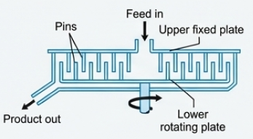
- Mechanism: It operates through both impact and attrition (shear forces from moving surfaces).
- Construction: It consists of two horizontal steel plates with vertical pins arranged in concentric circles. The pins of the two faces intermesh.
- Working: One or both plates rotate. Material is fed into the center and propelled through the intermeshing pins by centrifugal force, breaking the particles as they pass.
- Limitation: Large volumes of air are drawn through the mill, which must be managed by a separator.
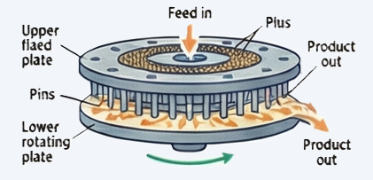
- How to Overcome: Control the solids feed rate and air flow rate to achieve the desired particle size.
- Advantages: It is screen-less and therefore clog-free; it also maintains lower temperatures than many other mills.
- Pharmaceutical Applications: Ideal for grinding soft, non-abrasive powders and heat-sensitive substances.
Ball Mill
- Introduction: A horizontally rotating vessel used for fine and ultrafine grinding.
- Mechanism: It uses attrition (at low speeds) and impact (at higher speeds).
- Construction: A hollow cylindrical vessel partially filled with steel balls or pebbles which act as the grinding medium.
- Working: As the mill rotates, the balls are carried up the sides and fall onto the material. The most efficient grinding occurs at the "optimum speed" where balls cascade over one another.
- Critical Operating Parameters:
  - Critical speed is the most vital parameter—the speed at which the balls begin to centrifuge with the mill casing. Effective milling usually occurs at 60% to 85% of this critical speed. Other factors include the ball charge (30% to 50% of volume) and ball density.
- Limitation: It is a batch process with long milling times, and the balls can contaminate the product with particulate matter.
- How to Overcome: Use stainless steel balls to minimize contamination, or use a vibro-energy mill to achieve faster results through vibration.
- Advantages: Can be used for wet or dry milling; it is unsurpassed for fine grinding of hard, abrasive materials.
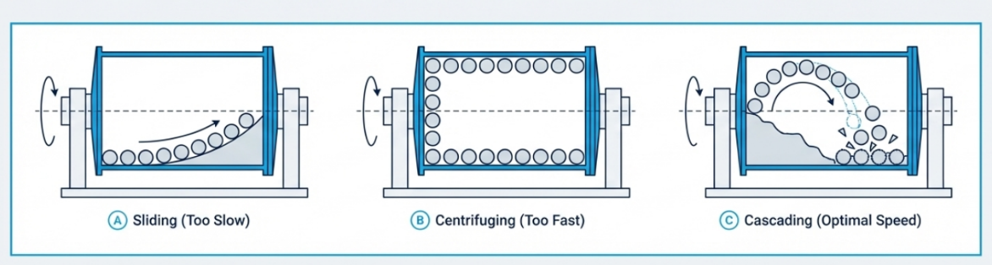
- Pharmaceutical Applications: Used for fine grinding, creating ophthalmic and parenteral products (as it can be sterilized and sealed), and processing explosive materials in inert atmospheres.
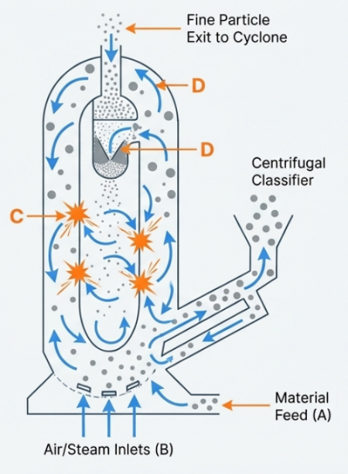
Fluid-Energy Mill (Micronizer) and Spiral Jet Mill
- Introduction: This equipment is used to produce extremely fine powders, often called "micronization".
- Mechanism: Size reduction occurs through impact and attrition, primarily through high-velocity collisions between the particles themselves.
- Construction: It consists of an elliptical pipe with nozzles that inject compressed air or steam at high pressures (100 to 150 psi).
- Working: Material is fed into the high-velocity stream. The violent turbulence causes particles to strike each other and break. Smaller, lighter particles are discharged, while heavier ones stay in the loop.
- Limitation: It has high capital and operating costs, and nozzles can become blocked.
- How to Overcome: The feed should be pre-milled to 20- to 100-mesh size to facilitate the micronization process.
- Critical Operating Parameters: Grinding fluid pressure, feed rate, and the number/angle of the nozzles.
- Advantages: There are no moving parts, and the cooling effect of expanding air counteracts the heat of milling, making it perfect for heat-sensitive drugs. An integrated classifier collects fine particles (often 5 um or less) from the center. In the spiral jet mill, a tangential gas flow creates a vortex for autogenous grinding.
- Pharmaceutical Application: Used for micronization (reducing particles to 1–20 µm) of moderately hard and friable materials. It is excellent for thermolabile materials because the expanding gas has a cooling effect.
Homogenization Mechanisms
Homogenization is used to mill particles in a suspension or emulsion using shear, turbulence, and cavitation.
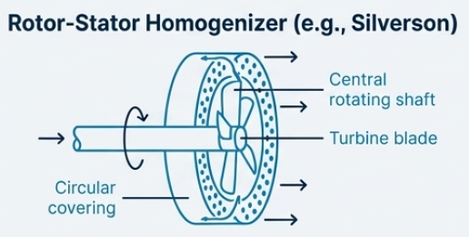
Silverson Homogenizers
- Introduction: A high-shear mixer used to mill particles in a suspension or create emulsions.
- Mechanism: It uses intense shear and turbulence generated by high-speed rotation.
- Construction: It has a high-speed rotating impeller inside a stationary housing (the emulsifying head) that is fitted with a circular mesh or perforated grid.
- Working: The rotation sucks material into the head and expels it through the mesh at high velocity, subjecting it to maximum shear in the narrow gap between the rotor and stator.
- Limitation: Some particles might escape the highest shear zones during a single pass.
- How to Overcome: Use restricting grids as small as 0.5 mm or use multiple passes to ensure all material is processed.
- Critical Operating Parameters: Pressure levels (500 to 5,000 psi) and the gap size of the valve or rotor/stator.
- Advantages: It offers various configurations to increase the probability that all particles pass through high-shear zones.
- Pharmaceutical Applications: Used for making liposomes, nano-suspensions, and tablet coating dispersions.
- Primary Mechanism: Shearing, turbulence, and cavitation.
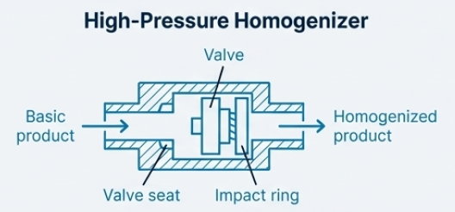
- High-pressure homogenizers force the fluid through a narrow, adjustable gap (valve). The rapid pressure drop and high velocity cause intense turbulence, shear, and cavitation, which disrupts particles and droplets.
  - Application: General-purpose dispersion, emulsification, and suspension preparation.
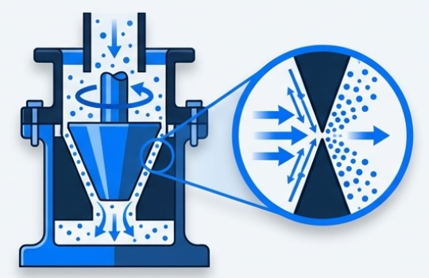
Colloid Mill
- Primary Mechanism: Shearing.
- Principle of Operation: A high-speed (3,000-20,000 rpm) conical rotor spins within a stationary stator. The material passes through the extremely narrow, adjustable gap (0.005-0.075 cm) between them, experiencing intense shearing forces, where one surface moves at a very high angular velocity.
- Critical Operating Parameters: The clearance between the rotor and stator.
- Application: Always used with a liquid. Essential for preparing pharmaceutical suspensions and emulsions, producing particles less than 1 micron. Specialized for wet grinding and producing fine dispersions.
Vibro-energy Mill:
- These mills use a three-dimensional vibratory field to induce comminution primarily by attrition. They generally produce a narrower particle size distribution and operate at lower temperatures than standard ball mills.
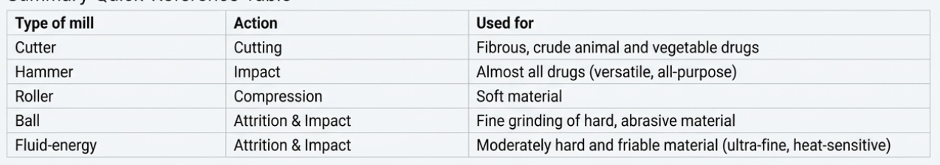
Particle Size Distribution
Milling does not produce particles that are all the same size; instead, it results in a size-frequency distribution.
- Distribution Shifts: As milling progresses, a material that started with one main size peak (monomodal) typically develops two peaks (bimodal) as larger particles are preferentially broken down.
- Statistical Average: Because milled particles are irregular in shape, their size is expressed using statistical diameters, such as the Stokes’ diameter (based on how fast they settle in liquid) or the volume-surface mean diameter.
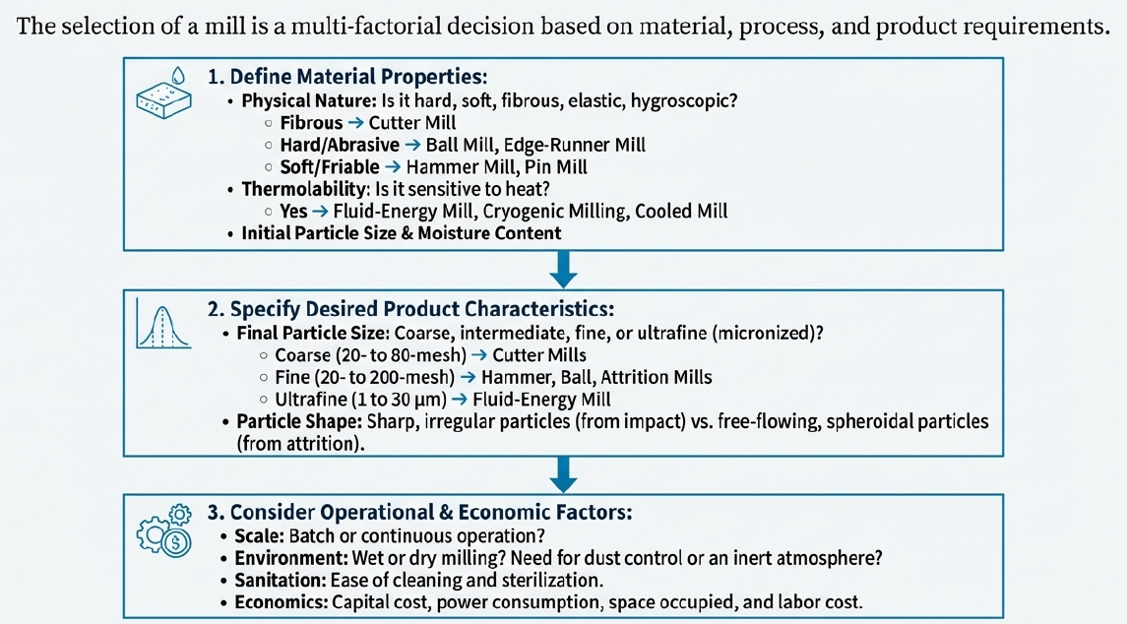
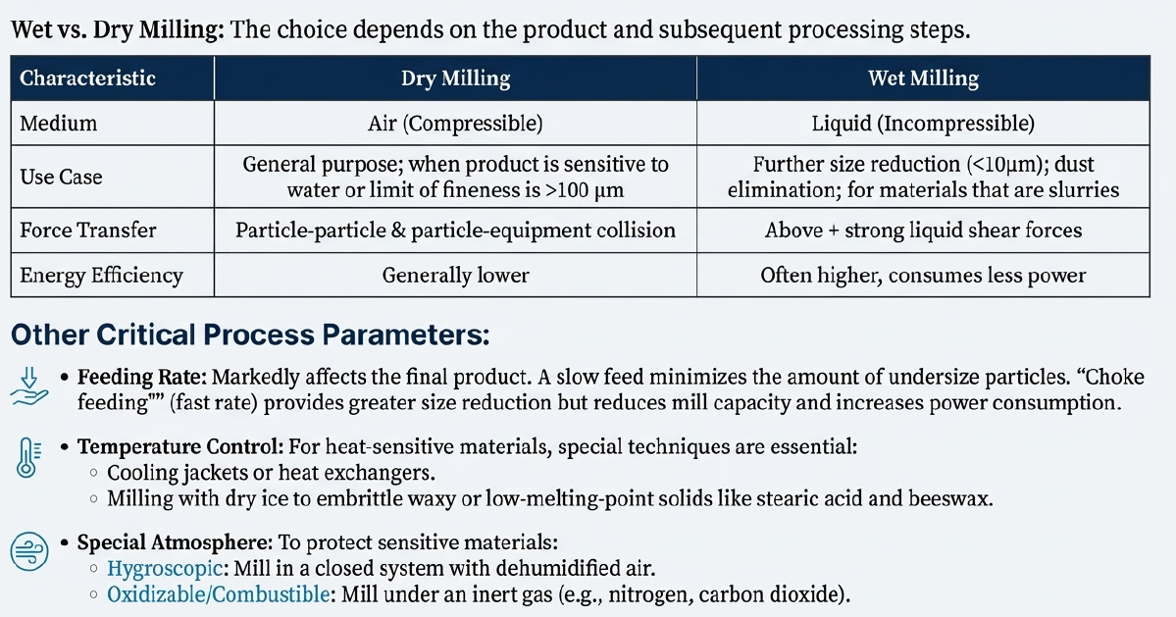
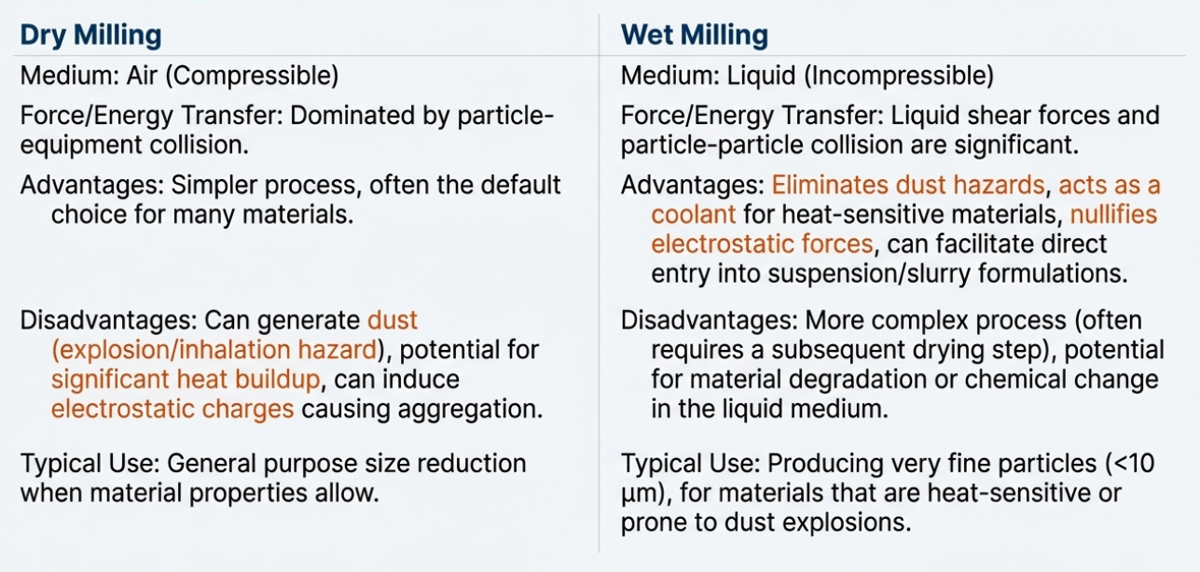
Factors Affecting Milling

The efficiency of the milling process are influenced by a complex interplay of the physical properties of the material and the operational parameters of the equipment.
1. Nature of the Material
The physical characteristics of the substance determine which milling mechanism (cutting, compression, impact, or attrition) is most effective.
- Hard and Abrasive Materials: Substances like iodine and pumice cause rapid wear of mill parts and require specialized equipment.
- Fibrous Materials: Materials such as Glycyrrhiza or Rauwolfia cannot be crushed by pressure or impact; they must be cut using equipment like a cutter mill.
- Friable Materials: Substances like sucrose or dried filter cake fracture easily along well-defined planes and can be milled by most mechanisms.

- Elasticity and Plasticity: Polymeric materials may exhibit hysteresis, where the energy applied is dissipated as heat rather than causing a fracture. Materials may respond as brittle to rapid impact but as plastic to slow forces.
2. Moisture Content
The amount of water present significantly affects the flow and "grindability" of the powder.
- Stickiness: A moisture content of more than 5% generally hinders comminution and often produces a sticky mass.
- Wet vs. Dry Milling: Dry milling typically requires moisture levels below 2%. Conversely, if moisture exceeds 50%, the material becomes a slurry or fluid suspension, requiring a wet milling process.

- Specific Sensitivities: Hygroscopic materials like calcium chloride absorb moisture rapidly and clog the mill. Some drugs, like Glauber’s salt, liberate water of crystallization at low temperatures, causing clogging.
3. Temperature and Heat Generation
Because less than 1% of the energy input in milling is used to create new surfaces—with the rest dissipated as heat, noise, and vibration—temperature control is vital.
- Material Degradation: Excessive heat can melt or soften waxes, synthetic gums, and resins. It may also degrade or char heat-sensitive drugs and change the shade of pigments.
- Safety Risks: High temperatures can cause finely powdered materials to ignite or explode.
- Mitigation: Cooling jackets, heat exchangers, or the addition of dry ice (which embrittles waxy materials) are used to manage temperatures.

4. Feeding Rate and Residence Time
The manner in which material enters and stays in the mill markedly affects the final product.
- Feeding Speed: A slow feed rate allows for ready discharge and minimizes the amount of "fines".
- Choke Feeding: If the mill is fed at a fast rate, the discharge is impeded by the mass of the material. This increases residence time in the chamber, leading to a greater reduction in particle size but also reducing the mill's capacity and increasing power consumption.

- Milling Limit: With prolonged milling, the probability of a particle being involved in a fracture diminishes, eventually reaching a practical milling limit where further energy expenditure is useless.
5. Operational Parameters of the Equipment
- Rotor Speed: In hammer mills, speed is crucial; below a critical impact speed, the rotor turns too slowly and acts as a blender rather than a mill. Higher speeds generally shift the size-frequency curve toward smaller particles.
- Screen Design: A smaller screen opening or a thicker screen produces smaller particles because the path of exit for the particle is more restricted.
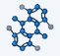
- Ball Mill Variables: Efficiency in a ball mill depends on the ball charge (ideally 30–50% of volume), the material-to-void ratio, and the size/density of the balls. Smaller, denser balls (like steel) generally provide faster and finer grinding than larger or lighter balls (like porcelain).
6. Polymorphism and Chemical Stability
Milling can induce unintended physical and chemical changes in the material:
- Crystalline Alterations: Milling may change the crystalline structure or form metastable states, leading to crystal growth (caking) during storage.
- Molecular Breakdown: High-energy milling can break down polymers like starch or povidone into lower molecular weight units.
- Chemical Reactions: Some substances, such as certain fatty acids, may be decarboxylated due to the energy and heat of the milling process.
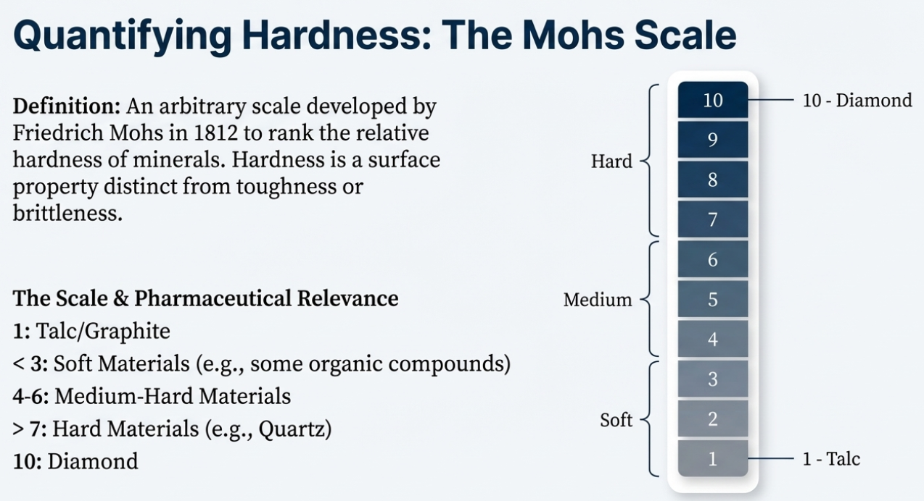

Particle size determination and distribution analysis
Determining the size of particles is essential in pharmacy because it affects how well a drug dissolves, how it flows through machines, and even its therapeutic effect. The sources describe several techniques for quantifying particle size distribution, categorized by whether they measure particle number, weight, volume, or light scattering.
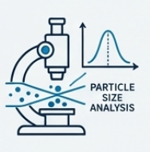
1. Microscopy
Microscopy is the most direct method for measuring particle size distributions.
- Operating Ranges: Using ordinary white light, it measures particles from 0.4 to 150 µm. This can be extended to 0.1 µm with ultraviolet light, 0.01 to 0.2 µm with an ultra-microscope using dark-field illumination, and as low as 0.01 µm with electron microscopy.
- Procedure: Particles are measured along an arbitrary fixed line using a calibrated filar micrometer eyepiece or reticules with grids of circles and squares.
- Statistical Requirements: To ensure accuracy, at least 625 particles should be counted for wide distributions, though as few as 200 may suffice for narrow distributions.
- Advantages/Disadvantages: While it allows for direct observation of particle shape and aggregates, it can be tedious; automatic scanners and photomicrographs are often used to reduce operator fatigue.
2. Sieving
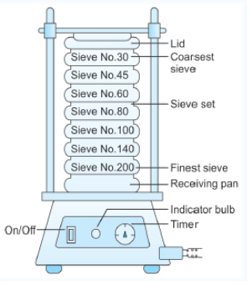
Sieving is the most widely used method because it is inexpensive, simple, and rapid.
- Operating Range: Primarily used for particles larger than 50 µm, though micromesh sieves can extend this down to 10 µm.
- Standards: Two common standards are the Tyler Standard Scale and the US Standard, both based on the number of openings per linear inch (mesh).
- Procedure: A sample is subjected to mechanical shaking through a series of successively smaller sieves. The weight retained on each sieve is then weighed.
- Data Collection: After shaking, the amount of material retained on each sieve is weighed. The size assigned to the particles on a specific sieve is typically the average of the openings of that sieve and the one directly above it.
- Critical Factors: The type of motion (vibratory is most efficient), the duration of sieving, and the load/thickness of the powder must be standardized.
3. Sedimentation and Elutriation
These methods relate the size of a particle to its behavior in a fluid medium.
Sedimentation (Andreasen Pipet):
Sedimentation is a weight-based method used to determine particle size and distribution, primarily across a size range of 1 to 200 µm. It is an essential analytical technique in pharmacy because sedimentation is a critical property of pharmaceutical suspensions, and the size of suspended solids is most accurately expressed through this mechanism as the Stokes’ diameter.
Fundamental Principles and Stokes' Equation
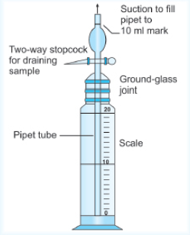
The sedimentation method is based on the physical dependence of the rate of sedimentation on particle size. This relationship is governed by Stokes’ equation, which is used to calculate the effective or Stokes’ diameter d_{stokes}:
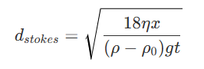
In this equation, η represents the viscosity of the dispersion fluid, x/t is the rate of sedimentation (distance $x$ fallen in time t), g is the gravitational constant, and ρ and ρ₀ are the densities of the particle and the medium, respectively. This equation is applicable to free spheres falling at a constant rate, provided the suspension concentration is low—generally not exceeding 2%—to ensure particles settle independently without significant interaction. The Stokes' diameter is defined as the diameter of a sphere that requires the same amount of time as the irregular particle to settle between two fixed points in a liquid.
The Andreasen Pipet Method
The Andreasen pipet is the most common and simplest apparatus for incremental particle size analysis via sedimentation.
- Experimental Setup: A 1% suspension of the powder is prepared in a suitable liquid and placed into the pipet.
- Settling Process: Because particles in a milled or natural powder are not uniform, they settle at different rates, with larger particles falling faster and passing the sampling tip sooner than smaller ones.
- Sampling and Analysis: At measured time intervals, 10 ml samples are withdrawn by aspiration from a fixed depth. These samples are then dried, and the weight of the residue is recorded.
- Concentration Changes: As the process continues, each successive sample has a lower concentration and contains particles of a smaller diameter than the previous sample.
Data Processing and Statistical Representation
The weight of the dried residue from each sample allows for the calculation of the percentage of the initial suspension that consists of particles smaller than the diameter calculated for that specific time interval.
- Cumulative Weight Undersize: The sum of successive weights is known as the cumulative weight undersize, which is used to plot a size-weight distribution curve.
- Probability Plots: Plotting the logarithm of size against the cumulative percentage undersize typically produces a straight line on a probability grid.
- Statistical Values: This plot enables the evaluation of the geometric mean diameter (read at the 50% value) and the geometric standard deviation (calculated as the ratio of the 84.13% size to the 50% size).
- Conversions: Using the Hatch-Choate equations, the weight distribution data obtained from sedimentation can be mathematically converted into a number distribution, such as the mean surface diameter (ds).
Specialized Sedimentation Techniques
When gravity alone is insufficient for analysis, alternative sedimentation-based methods are employed:
- Centrifugation: This method is used for very small particles in the 0.05 to 5 µm range. At these micro-scales, normal gravity sedimentation is extremely slow, and Brownian motion can interfere with accurate settling. Applying centrifugal force instead of gravitational force greatly increases settling velocities, allowing for the analysis of colloidal-sized particles.
- Elutriation: This is essentially the reverse of sedimentation. The fluid moves in a direction opposite to the settling movement (vertically upward). If the upward velocity of the fluid is higher than the settling velocity of a particle, that particle is carried upward. By using a series of vessels with increasing diameters, the fluid velocity decreases in each subsequent vessel, allowing particles of decreasing size to be separated into different fractions.
4. Coulter Counter (Volume Determination)
The Coulter counter is a sophisticated method for the quantification of particle size distribution based on the determination of the volume of particles. Unlike methods that rely on number counts (microscopy) or weight (sieving/sedimentation), the Coulter counter is unique because it measures a property—volume—that has a direct relationship with the physical mass of the particle.
Principle of Operation
The fundamental principle of the Coulter counter is the measurement of electrical conductivity. The process involves the following steps:
- Suspension: The particles are suspended in an electrically conductive fluid (an electrolyte).
- Aperture and Electrodes: This suspension is allowed to flow through a small, suitable aperture that has an immersed electrode on either side.
- Particle Concentration: The concentration of the suspension is meticulously arranged so that only one particle travels through the aperture at any given time.
- Electrolyte Displacement: As a particle passes through the aperture, it displaces its own volume of electrolyte. This displacement changes the electrical resistance between the two electrodes, which in turn causes a pulse in the voltage.
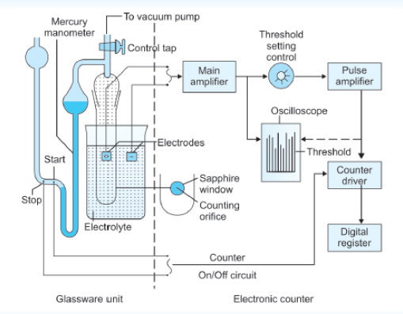
Signal Processing and Data Collection
The magnitude of the voltage pulse generated is directly proportional to the volume of the particle.
- Amplification and Thresholds: These changes in voltage are amplified, and only impulses that exceed a predetermined threshold value are counted.
- Oversize Counting: By setting the recorder to different threshold values, the instrument can provide a count of the number of particles that are oversize to a specific series of pre-determined values.
- Equivalent Sphere Calculation: Because the measurement is volume-based, it is a simple mathematical matter to calculate the diameter of a sphere of equivalent volume.
Advantages and Operational Benefits
According to the sources, the Coulter counter offers several significant advantages over other determination methods:
- Reliability and Speed: The operation is very rapid, and because a large number of particles (often thousands) are counted in a single run, the results are statistically more reliable than manual counting.
- Reduction of Human Error: The operational simplicity of the instrument reduces operator variables, leading to highly reproducible results.
- Versatility: It can be used for a wide variety of pharmaceutical materials, provided they can be successfully suspended in a conductive electrolyte.
Technical Specifications and Range
The Coulter counter is highly effective for a broad range of particle sizes.
- Particle Size Range: The instrument can operate with particles between 0.5 and 1,000 µm.
- Schematic Representation: The system typically consists of a glassware unit (including the electrolyte reservoir and counting orifice) connected to an electronic counter containing a pulse amplifier, threshold setting control, and a digital register.
5. Dynamic Light Scattering (DLS)
Dynamic Light Scattering (DLS), also known as photon correlation spectroscopy, is a specialized technique that has become the mainstay for the determination of particle size and size distributions, particularly in the sub-micron range. While other methods like sieving or sedimentation handle larger particles, DLS is specifically optimized for the nanosize range of 0.01 to 1 µm.
The Fundamental Principle of Light Interaction
The operation of DLS begins with the interaction between light and matter. When a beam of light is directed at a particle, the light is either deflected or absorbed, a phenomenon that depends heavily on the size of the particle relative to the wavelength of the incident light.
- Large Particles: Particles that are significantly larger than the wavelength of light tend to diffract the light.
- Small Particles: Particles that are close to the size of the wavelength, or smaller, tend to scatter the light.
Most DLS measurements are conducted on dilute particle dispersions rather than individual single particles to ensure accurate scattering patterns.
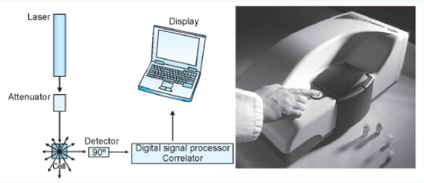
The Role of Brownian motion
The "Dynamic" aspect of DLS refers to its reliance on the theory of Brownian motion, which is a unique characteristic of colloidal particles.
- Mechanism: DLS measures the velocity of particles in constant, random motion within a liquid. Because this motion is not affected by settling forces in such small particles, the instrument can correlate the velocity of the particle directly to its size.
- Radiation Source: The instrument utilizes laser light as a radiation source. As the particles move, the frequency of the scattered light varies; the system detects these variations and correlates them to particle velocity to calculate size.
Operational Requirements and Assumptions
To obtain accurate data, the DLS method relies on specific mathematical and physical parameters:
- Spherical Assumption: The underlying theory of DLS assumes that the particles being measured are spherical in shape.
- Refractive Index: For the calculation to be valid, the refractive index of both the particles and the dispersion medium must be known.
- Applications: Beyond solid particles, this technique is frequently used to determine the droplet size of emulsions and microemulsions.
Instrumentation and Advantages
A typical DLS setup (as seen in Figure 2.29 of the sources) includes a laser source, an attenuator, a sample cell, a detector (often positioned at a 90° angle), and a digital signal processor/correlator connected to a computer for data display.
- Simplicity: DLS is considered a relatively simple and inexpensive technique for modern laboratories.
- Automation: Modern units feature computer-controlled acquisition and analysis, making the process highly efficient.
- Range: It is the primary choice for materials in the 0.01–1 µm range, filling the gap where optical microscopy and sieving are no longer effective.
Data Representation and Statistical Analysis
Once data is collected, it is represented through various mathematical and graphical means to characterize the powder.
- Mean Diameters: Common measures include the arithmetic average diameter (sum of diameters divided by the number of particles), the geometric mean (the nth root of the product of all diameters), and the median (the size for which 50% of particles are smaller).
- Distribution Curves: Data is often plotted on a size-frequency distribution curve. Milled materials usually show a "skewed" distribution, with a higher number of particles at smaller sizes.
- Hatch-Choate Equations: These equations are vital for converting one type of distribution to another. For example, data obtained from microscopy (number distribution) can be mathematically converted to a weight-mean or surface-mean diameter using the geometric standard deviation.
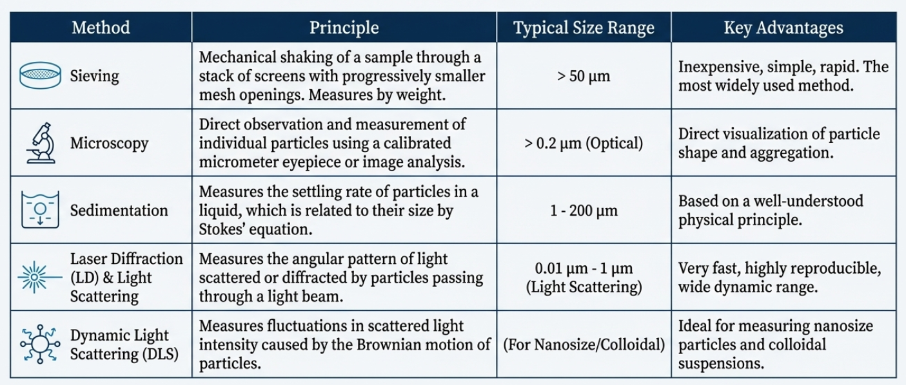

To conceptualize these methods, think of Sieving like using different-sized colanders to sort pasta, Stokes' sedimentation like watching how long it takes different-sized beads to sink in a jar of honey, and the Coulter Counter like a precise turnstile that measures exactly how much room each person takes up as they pass through.
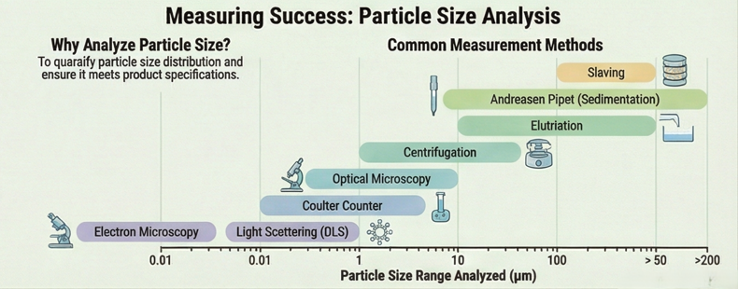

Summary of Analysis Methods
Method | Measuring Principle | Particle Size Range
Sieving | Weight/Mechanical Separation | > 50 µm
Microscopy (Optical) | Direct Number Count | > 0.2 µm (0.4–150 µm)
Microscopy (Electron) | Direct Number Count | > 0.01 µm
Andreasen Pipet | Weight/Sedimentation (Gravity) | 1–200 µm
Centrifugation | Weight/Sedimentation (Centrifugal) | 0.05–5 µm
Coulter Counter | Volume/Conductivity | > 0.5 µm (0.5–1,000 µm)
Light Scattering (DLS) | Scattering/Brownian Motion | 0.01–1 µm

